Unique Handicap Scheme

The runbritain Handicap gives all runners of all abilities the chance to record their progress & compare their results across a variety of distances & terrains
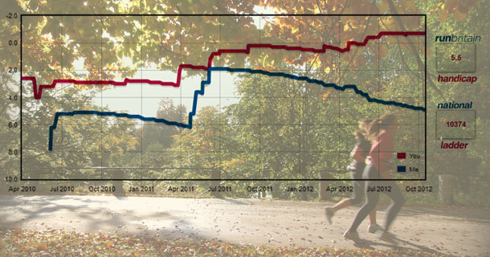

runbritain's revolutionary handicap scoring system is designed to give runners of all abilities the ability to benchmark their progress and compare their results across a range of distances and terrains.

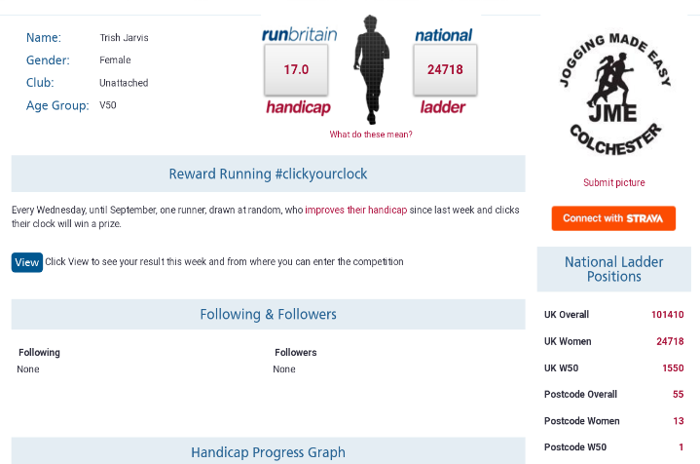
We include road, multi-terrain, track, cross country and trail races so now nearly all events that are licensed by UKA/runbritain can contribute to your handicap. The algorithm we use allows a direct comparison of the current form of different runners to be made. It does not matter if the races if you do were in tough, moderate or fast conditions as the algorithm assesses the difficulty of the course on the day so that you have as good a chance of improving your handicap on a hilly course on a tough day to a flat course on a calm day.

The scoring system, which has been developed in conjunction with the team behind the Power of 10 website, rewards regular racing and factors in a degree of difficulty for slower courses.
5m Handicap

The score is derived from all your race results in UKA licensed road, multi-terrain, track & cross-country races from 2010 although you only need to have done one race since 2010 to claim a handicap.

Once registered, https://www.runbritainrankings.com/ you just need to log in to be taken to your bespoke personal running blog profile page featuring:

* opportunity to enter the monthly Reward Running 2018 competition (from April)
* personal progress graph
* direct comparisons with other runners with a 'head-to-head' function
* weekly mileage logger and graph
* national ladder position showing your ranking amongst all UK runners
* current rankings at each of the major distances (5K, 10K, HM, Mar)
* handicap score updated automatically after each run
* target times to bring score down to the next level
* training schedules to help you achieve your targets

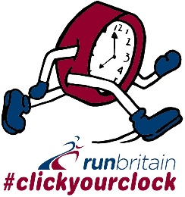

In 2018, each week from March to September, one runner drawn at random from all those that have improved their handicap that week and have clicked their clock will receive a prize.

The competition uses the results of all runbritain licensed events (including parkruns), each Wednesday to the following Tuesday, that have been uploaded by 12 noon each Wednesday. There will be an additional column, that conceals a clock, alongside your result. By clicking it, it will reveal the percentage change in your runbritain handicap score compared to that last week.

Results of events taking place up until 5pm on a Monday are expected to be listed before noon on Wednesday, depending on the race organiser's timing in making available full results to us.

To enter the competition, you must have:
- claimed your handicap and then login
- completed a runbritain licensed race or parkrun this week
- clickyourclock on the relevant results page to enter
- entered before 12 noon each Wednesday

The leaderboard will be displayed until the competition closes at precisely 12 noon each Wednesday. After then the prize winner will be drawn at random and we will contact that person by email to arrange delivery of the prize.

If any prize winner has not responded to the email notification by 5pm Friday, the prize will roll over to the next week and the runbritain Reward Running competition will continue for another week.

